# BREAKING

**METRO SPORTS BUSINESS & TECH OPINION**

WELCOME, JOHN

**TODAY'S PAPER**

**Check out this week's virtual events**

RSVP now

**LAWMAKERS STRIKE DEAL TO RESTORE PANDEMIC-ERA POLICIES, INCLUDING EVICTION PROTECTIONS, TO-GO COCKTAILS**



Red Sox 10, Braves 8, Final



**LEARNING CURVE**

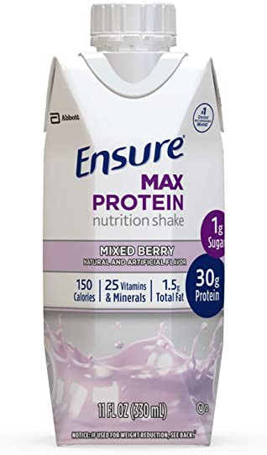

*30g protein and nutrients to support immune health*

10% off coupon

Ensure Max Protein Nutritional Shake with 30g of …

Facebook creator, wife inspired by Dorchester school

**By James Vaznis** Globe Staff, January 26, 2016, 8:22 p.m. **12**



Teacher Charlyn Cuffy worked with students in a measurement match class at the Codman Academy Charter School in Dorchester. DAVID L. RYAN/GLOBE STAFF/GLOBE STAFF

Learning Curve: A Boston Globe project



*The Globe is taking a year-long look at promising practices to address a range of social, emotional, and cultural issues in Massachusetts public schools that could be affecting classroom achievement. The series is being produced in partnership with the Solutions Journalism Network, with funding by the Nellie Mae Education Foundation. To see previous coverage, click here.*

Doctors in white coats mingle with students in the hallways and cafeteria. A school nurse is on hand to take sick students to an urgent care room if their parents cannot leave work right away. Students receive free dental care and vision screenings.

For more than a decade, Codman Academy Charter School has ventured where few public schools nationwide have tread by forging a partnership with a community-based health center. The high school grades are inside the Codman Square Health Center; its elementary- and middle-school programs are across the street.

Now, the Dorchester school is serving as a source of inspiration for Priscilla Chan and her husband, Facebook creator Mark Zuckerberg, who are preparing to open a tuition-free private school for low-income students in East Palo Alto, Calif., in the fall. Like Codman Academy, the couple’s Primary School will partner with a community health center.

Advertisement

**BOSTON GLOBE VIDEO**



2:23

Baker announces ‘VaxM SHARE

Chan did part of her rotation as a pediatric physician at Codman, and now the school and the new one in

**Related**

**More from the Learning Curve special section**

Governor Charlie Baker announced residents who are fully vaccinated against COVID-19 will have the chance to win $1 million in a special Lottery sweepstakes. (Photo by Matt Stone/Boston Herald via AP)

California are part of a wave of formalized partnerships between educational

institutions and health services. The schools are a response to emerging research that shows growing up in poverty could slow brain development because of such potential factors as poor nutrition, lack of sleep, or stress associated with living in households touched by violence.

**s ns’**

**rd**

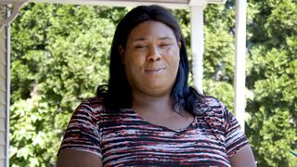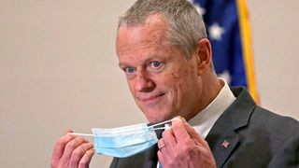

**Baker Moose What announce spotted Black ‘VaxMillio on liberation lottery Route 3 means program in to me:**

**Chelmsfo Athena**

**Vaughn**

**NOW PLAYING**

# Get Today's Headlines in your inbox

The day's top stories delivered every morning.

Enter Email



[example@email.com](mailto:example@email.com)

**Sign Up**

Earlier this month, the US departments of Education and Health and Human Services, in releasing new guidance on ways to boost students’ well- being, proposed creating more school-based health clinics or partnerships with nonprofit community hospitals.

William Walczak, a founder of Codman Square Health Center and the charter school, said that whenever he goes to health industry conferences he encourages attendees to steal the idea of integrating a community health center with a public school.

“The real issue is how do we make more middle-class people out of students growing up in poverty?” said Walczak, who remains president of the school but no longer runs the health center. “Providing health care wasn’t transforming the community. If we really wanted to make more of a difference in this community, we needed to get into education.”

Advertisement

**MOST POPULAR ON BOSTONGLOBE.COM**

1. Baker announces ‘VaxMillions’ lottery program, offering $1 million cash prizes to boost vaccination rates
2. Message in a bottle, tossed into the sea in Rhode Island, found in Azores
3. Life sciences is poised to be Boston’s dominant industry. Has the area become the Silicon Valley of biotech?
4. The downside of ditching masks: the return of colds, flu
5. The case for prosecuting Donald Trump
6. How white supremacy weaponizes ignorance
7. A treasure map for an American tyrant
8. ‘Boo Boo’ the South Shore Bear captured on video roaming in Duxbury
9. Paul Pierce to launch ‘Truth’ marijuana brand in Massachusetts
10. 5 things to know about the VaxMillions lottery sweepstakes in Mass.

At Codman Academy, the goal of the partnership goes beyond providing health services to students. Officials also want to expose students to careers in the health fields, which often provide salaries to lift students out of poverty. Roughly 20 percent of jobs in Boston are in the health industry.

Dozens of Codman students every year take part in internships at the health center or other hospitals, while all high school students, taking their classes inside the center, get to see firsthand what it is like to be in a professional work environment.

Emmanuel Obianigwe, a Codman senior, said he never considered a career in the health field until becoming a summer intern last year in the center’s pediatric department, where he performed such routine office tasks as making follow-up phone calls and scheduling appointments. Now, he is thinking about pursuing pre-med in college.

He said he has grown up quite a bit since he started at Codman Academy.

“I have a very imposing personality. I like to get my point across But

throughout my time here, they helped me a lot,” said Obianigwe, of Roslindale.

Many educators say that connecting schools with medical institutions makes sense, especially in urban areas where families might lack health care. One of the leading contributors to students being chronically absent from school is health-

Yolanda Burrell (left), clinical care

related problems, such as asthma attacks, dental coordinator, and Dr. Elizabeth

Powell, dental director, offered free

problems, and trauma.

dental services to students at the academy. DAVID L. RYAN/GLOBE STAFF/GLOBE STAFF

Advertisement

And many of those students already are at an academic disadvantage.

“Those kids who are not provided with an environment that offers supports like those offered at Codman will continue to build up layers of toxic and performance-dimming experiences that are hard to recover from,” said Jerome Schultz, a clinical neuropsychologist and a lecturer at Harvard Medical School.

Consequently, poor students tended to score four to seven points lower on standardized tests than their more affluent peers.



**VIEWS FROM OUR COLUMNISTS**

**YVONNE ABRAHAM**

Energy efficiency is a low- hanging fruit to combat climate change. So why can’t everyone get access to it?

**KEVIN CULLEN**

Bill Bratton on American policing and the challenge facing the Boston Police Department

**THOMAS FARRAGHER**

A salute across the ages to an old squad leader

**SHIRLEY LEUNG**

A working mother’s manifesto: Pandemic provides a once-in-a- generation chance to course correct how we work

**JENEÉ OSTERHELDT**

Juneteenth and the meaning of Black liberation in Boston

**ADRIAN WALKER**

‘The best Boston movie no one’s ever seen’: ‘Blue Hill Avenue’ at 20

Last year, a team of researchers who analyzed 823 magnetic resonance imaging scans from hundreds of children and young adults from a variety of socio-economic backgrounds concluded that children growing up in poverty had slower development of gray matter — the area of the brain responsible for processing information.

“Students living in poverty are not arriving to school in the morning on a level playing field,” said Seth Pollak, one of the study’s authors and a psychology professor at the University of Wisconsin Madison. “They are hungry, tired, stressed. No one is reading to them at home. The children we were studying didn’t even have crayons or Magic Markers at home.”

Such research findings prompted Chan and Zuckerberg to pursue their private school venture.

Chan, who is leading the effort, was not available for an interview because she is on maternity leave, but she wrote about the couple’s motivations to start the Primary School on her Facebook page in October. It will be a K-8 school that will also feature an early childhood program.

Advertisement

Chan, a graduate of Quincy High School and Harvard University, gained some insight while in the Boston area. She oversaw an afterschool program in a Boston neighborhood in addition to her stint at the Codman Square Health Center.

“My experiences of running an afterschool program in a low-income housing project and working as a pediatrician in a safety-net hospital [have] shown me firsthand that we need a better way of caring for and educating our children,” Chan wrote. “The effects of trauma and chronic stress create an invisible burden for children that makes it very difficult for them to be healthy and live up to their academic potential. We must address these issues holistically in order to allow children to succeed.”

Over the past year, she has repeatedly visited Codman Academy and the health center as she developed the Primary School proposal. She also has been looking at the Harlem Children’s Zone in New York, a large-scale effort that connects education and health over dozens of city blocks.

Assisting Chan with her efforts has been Meredith Liu, a former Codman Academy administrator who is now the Primary School’s president.

Chan and Zuckerberg are starting their school after their $100 million investment in the Newark schools five years ago led to mixed results. The private school venture will give them more control over their investment.

Advertisement

Codman Academy, which opened in September 2001, started with just 32 ninth-graders, eventually filling out the high school grades over the following three years. It’s K-8 program opened in fall 2013.

Almost all of the school’s 320 students are black or Latino, and about half receive some kind of government welfare assistance.

On a tour of the K-8 program, located in a refurbished building, Meg Campbell, the academy’s executive director and co-founder, talked about how school officials declined to paint the walls bright colors typically found in elementary schools. Instead, they opted for natural hues featuring designs of tree twigs, giving a wilderness feel — quite a contrast with the urban environment outside its doors.

“It’s trauma-informed design. It has some healing value,” Campbell said, noting that primary colors are loud and can be unsettling for students suffering trauma. She added that Chan is planning on replicating the design at the Primary School.

Upstairs, an occupational therapist worked with two students on fine-motor skills, assigning them puzzles to assemble or shapes to cut out with scissors. In the hallway, a sullen boy slouched on a wooden bench, kicked out of a dance class.

“She’s not going to let me back in,” he said, nodding his head to the doorway where his classmates twirled inside.

Campbell sat next to him and in a soothing voice persuaded him to behave and escorted him back into the room.

Across the street, high school students gathered inside a black box theater for “Community Circle.” A highlight of the event was “Senior Talk,” during which 12th-graders delivered speeches that reflected on their lives and purpose. The talk is modeled after Socrates’ “Apology.

Omar Grey took to the podium on this particular day, which happened to be his 18th birthday. Wearing a brown striped sweater and a plaid shirt, he talked about how kids used to hurl racist remarks his way because of his dark skin and made fun of his occasional acne, speech impediment, and lack of money.

“I felt like I was the butt of every joke,” he said. “My lack of self-esteem impacted all parts of me.”

In an interview, Grey said Codman Academy helped him build confidence. He said a theater class was especially helpful in preparing him for public speaking.

“I’m ready to go out in the world,” he said.

The strategies do not always reach all the students. Four years ago, a 16- year-old boy killed himself in the bathroom at the school, devastating staff and students. The school, working with the health center and other partners, brought in counselors, and police conducted an investigation that ruled out foul play or bullying.

The school eventually began a communitywide discussion about suicide in hopes of helping those struggling with depression and invited a trauma center to screen students for risk of suicide and to train others to spot signs of suicidal tendencies.

The effort is part of the school’s mission of social justice, which galvanized students more than a decade ago to ban junk food at the school.

Eventually, the school would like to enroll infants and toddlers to complement programs at the health center for pediatric and prenatal patients, who take part in group visits to learn more about parenting.

“I really think the pendulum is swinging in the direction of really changing the lives of students,” Campbell said. “You need to integrate wraparound services so students can succeed. This is the cusp of what will be happening in the next 10 or 20 years.”

Codman Academy students participated in a dance class. The school has expanded to K-8 grades, while integrating Codman Square Health Center services. DAVID L. RYAN/GLOBE STAFF/GLOBE STAFF

[James Vaznis can be reached at jvaznis@globe.com. Follow him on Twitter](mailto:JamesVazniscanbereachedatjvaznis@globe.com.FollowhimonTwitter) @globevaznis.

**Show 12 comments**

**MORE ON GLOBE.COM**

**SPONSORED BY: STUDIO/B**

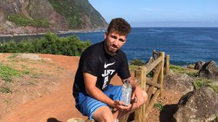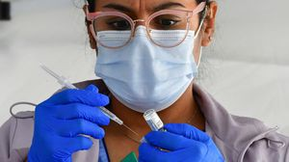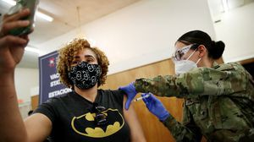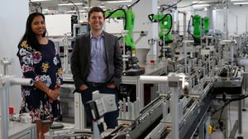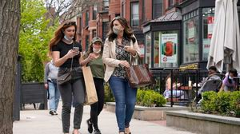

**These women are changing the world from here in Boston**

Meet the women behind breakthroughs that are shaping the future of science and medicine.

**A treasure map for an American tyrant**

Donald Trump exposed weaknesses

that a would-be dictator could exploit to end our democracy. It’s now up to lawmakers, voters, and public officials to prevent that from happening.

**RI NEWS**

**Message in a bottle, tossed into the sea in Rhode Island, found in Azores**

The note was written in 2018 by a 13-

year-old who was visiting family in Rhode Island.

**OPINION**

**I got the Johnson & Johnson vaccine. The pause makes me believe in it more.**

The worst thing that could happen now

is for the recommendation by the FDA and CDC to pause the vaccine’s administration to spur a new wave of vaccine hesitancy.

**5 things to know about the VaxMillions lottery sweepstakes in Mass.**

Here are five things you should know

about the VaxMillions program, which will make some lucky winners living proof that trusting the science really does pay.

**INNOVATION ECONOMY**

**Life sciences is poised to be Boston’s dominant industry. Has the area become the Silicon Valley of biotech?**

Since December, you can find six major

indications that Boston is the undisputed center of the life sciences industry, a place where ideas and products that change ― and save ― people’s lives around the world originate.

**‘Boo Boo’ the South Shore Bear captured on video roaming in Duxbury**

Duxbury police said on Twitter that a

resident living on Elm Street spotted Boo Boo in the backyard around 8:30

a.m. Tuesday, eating birdseed.

**Death penalty should be reinstated for Tsarnaev in Boston Marathon bombings case, Biden administration tells Supreme Court**

The Biden administration is asking the

Supreme Court to reinstate the death penalty against Dzhokhar Tsarnaev for the Boston Marathon terror bombings.

**America's blind spot: Thousands of drivers shouldn't be licensed** A Boston Globe investigation of how

bureaucratic negligence has left lethal

drivers on the road.

**The downside of ditching masks: the return of colds, flu** Since the state’s mask mandate was

lifted, face coverings have started to

come off — and stay off. But according to infectious diseases doctors, the return of facial freedom might come with some downsides, like a resurgence in cases of the common cold and the flu.

**MOST READ IN THIS SECTION**

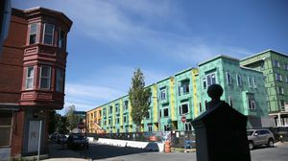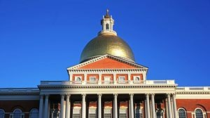

**America's blind spot: Thousands of drivers shouldn't be licensed**

**RI NEWS**

**Message in a bottle, tossed into the sea in Rhode Island, found in Azores**

**Death penalty should be reinstated for Tsarnaev in Boston Marathon bombings case, Biden administration tells Supreme Court**

**‘Boo Boo’ the South Shore Bear captured on video roaming in Duxbury**

**With housing at center of Boston mayor’s race, labor and developers are organizing to push candidates**

**5 things to know about the VaxMillions lottery sweepstakes in Mass.**

**State licensing loopholes keep thousands of bad drivers on the road**

**Lawmakers reach compromise on restoring pandemic era-policies including to-go cocktails, outdoor dining**

**Judge reinstates domestic violence charge against Boston police officer**

**FOLLOW US**

**SUBSCRIBE NOW MY ACCOUNT CONTACT MORE**

Digital Access Home Delivery Gift Subscriptions

Log In

Manage My Account Customer Service

Help & FAQs Globe Newsroom Advertise

Newsletters / View The EPaper /

Order Back Issues / News In Education / Search The Archives / Privacy Policy / Terms Of Service / Terms Of Purchase / Work At Boston Globe Media /

Do Not Sell My Personal Information



©2021 Boston Globe Media Partners, LLC